The Colony
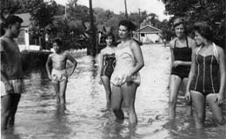Fifty years from now, what will the children of Oakland be remembering about the time, the people, and the place. For Saul Weitz, Bob Blumenthal and George Cohen, fifty years have come and gone, and the memories remain. As Spencer Tracy might say, “I can tell you the memories are still there- clear, intact, indestructible, and they’ll be there if I live to be 110.” The trio are on a mission to find others who can recall the bygone days of Oakland, specifically to what was, and is, known as The Colony.
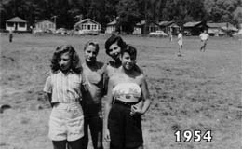For those unfamiliar with the term, The Colony refers to a development of housing on the other side of the river opposite the Rec Fields. It was originally a–yes, colony–of summer bungalows. The days of summer only residents is long gone, but The Coolony persists in it’s accessibility to nature, its communal design with open space, and with its rich history. The gentlemen are eager to hear from others who have memories of the special place in Oakland, and they have a website West Oakland. .
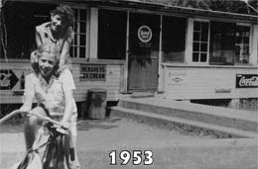There’s already an intriguing collection of photographs from the 1950s, and special recognition to Stanley Elkin who passed away in 1995. An accomplished author in both fiction and non-fiction, his books are readily available on Amazon. In a NYTimes interview for his book “The Rabbi of Lud” he recalls “My first 21 summers,” he said, ”were spent there in a bungalow colony in what was known as West Oakland, on the other side of the Ramapo River, and my grandmother ran a restaurant known as Aunt Eppy’s.” Readers may also find his last published work “The Age of Federalism” to be an excellent read for those interested in the beginnings of American government; it is described as a series of extended essays on crucial topics.
Readers ready and able to share memories of The Colony can contact Saul Weitz, Bob Blumenthal and George Cohen via their webpage, or through The Oakland Journal via email or our Submit page; or simply through leaving a comment below.
On another note, Kara Kivitt, whose grandparents moved here not long after they were married, is seeking photos of downtown Oakland from the 1950s. Oakland has always held many memories for her grandfather, but his last visit here was over 6 years ago. She is working on a project to build a scale model of Oakland in the 1950s and is seeking photos for this project. Readers with photos can contact The Oakland Journal via email or the Submit page.

