**The Morris Canal and the Oakland Farmer**

Question. Was there a feeder access from Pompton Lakes to the Morris Canal?

Top of Form

[**David T. Kearns**](https://www.facebook.com/profile.php?id=100001409043973)[https://static.xx.fbcdn.net/rsrc.php/v3/yA/r/_ZvGTxrlsmm.png](https://www.facebook.com/groups/345984765553500/badge_member_list/?badge_type=NEW_MEMBER) The Feeder, built by the Canal company in 1836-37, traveled 4 miles north to Pompton Plains, where it joined with the Ramapo River, ultimately bringing a supply of water to the canal from Greenwood Lake and the Ramapo. Citation, Images of America Morris Canal book.

[2](https://www.facebook.com/ufi/reaction/profile/browser/?ft_ent_identifier=ZmVlZGJhY2s6MTUwMjAxOTM2MzI4MzM2Ml8xNTAyMDIzMjU5OTQ5NjM5&av=100009305999629)

Hide or report this

[**Tim Roth**](https://www.facebook.com/tim.roth.54) Depends what you mean by access. Pompton Lakes was connected to the Pompton Feeder through the Ramapo River, where the northern outlet of the feeder connected a couple miles below the Pompton Lakes dam. The dam just below the outlet lock allowed for slackwater navigation a short distance upstream to the Pompton Ironworks, but not as far up as Pompton Lakes.

[2](https://www.facebook.com/ufi/reaction/profile/browser/?ft_ent_identifier=ZmVlZGJhY2s6MTUwMjAxOTM2MzI4MzM2Ml8xNTAyMzQ5MzQzMjUwMzY0&av=100009305999629)**[Joe Phalon](https://www.facebook.com/joe.phalon)** [Tim Roth](https://www.facebook.com/tim.roth.54?hc_location=ufi) Was the feeder navigable between Mountain View and the feeder dam?

[1](https://www.facebook.com/ufi/reaction/profile/browser/?ft_ent_identifier=ZmVlZGJhY2s6MTUwMjAxOTM2MzI4MzM2Ml8xNTA2MjkyMzIyODU2MDY2&av=100009305999629)

[**Tim Roth**](https://www.facebook.com/tim.roth.54) [Joe Phalon](https://www.facebook.com/joe.phalon?hc_location=ufi) Oh yes. There was a guard lock at the northern terminus of the feeder that allowed boats access to the Ramapo River, where they could navigate upriver a ways to the Pompton Ironworks. A dam, just below the lock, allowed for slack water navigation.

Hide or report this

[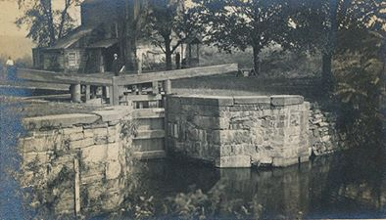](https://www.facebook.com/photo.php?fbid=10221947369462228&set=p.10221947369462228&type=3)

[1](https://www.facebook.com/ufi/reaction/profile/browser/?ft_ent_identifier=ZmVlZGJhY2s6MTUwMjAxOTM2MzI4MzM2Ml8xNTA2NzgyMjY2MTQwNDA1&av=100009305999629)

[**Tim Roth**](https://www.facebook.com/tim.roth.54) Remains of the lock still exist, as well as the replacement dam on the Ramapo.

Hide or report this

[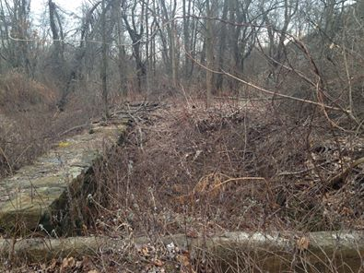](https://www.facebook.com/photo.php?fbid=10221947400503004&set=p.10221947400503004&type=3)

Bottom of Form