http://www.nj.gov/state/archives/pdf/proprietors.pdf

https://wwwnet1.state.nj.us/DOS/Admin/ArchivesDBPortal/NJProprietors.aspx

Joseph R. Klett
NEW JERSEY STATE ARCHIVES

Using the Records of the East and West Jersey Proprietors
www.continuingeducationnj.com/.../Jersey%20Roots%20JR%20Klett.pdf‎

by JR Klett - ‎2006 - ‎Cited by 1 - ‎Related articles
Ellen R. Callahan, Collection Manager at the New Jersey State Archives, ... the East and West Jersey Proprietors by Joseph R. Klett, New Jersey State Archives.

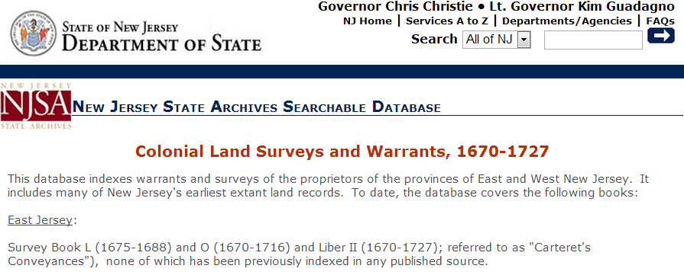

Robert West 1,000 Acres
George Willock 1,000 Acres
David Mudie 1,000 Acres
Thomas Gordon 500 Acres

Surveyor: Robert West

